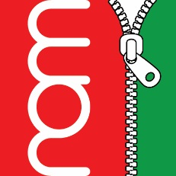

18th March 2020

Further to the Welsh Government’s announcement today, we have decided to close our shop to members of the public after Friday 20th March. We will continue to complete school uniform orders via our website: ourschoolwear.co.uk.
If you have any enquiries or school orders (e.g. leavers/trip hoodies), please contact us via email or telephone.
By taking these actions we are confident that all efforts have been made to present a safe environment as possible for staff. We would like to take this opportunity to thank you for your continued support.

